JAVA FSE ASSIGNMENT:

WEEK 02: JUnits

Exercise 1: Setting Up JUnit

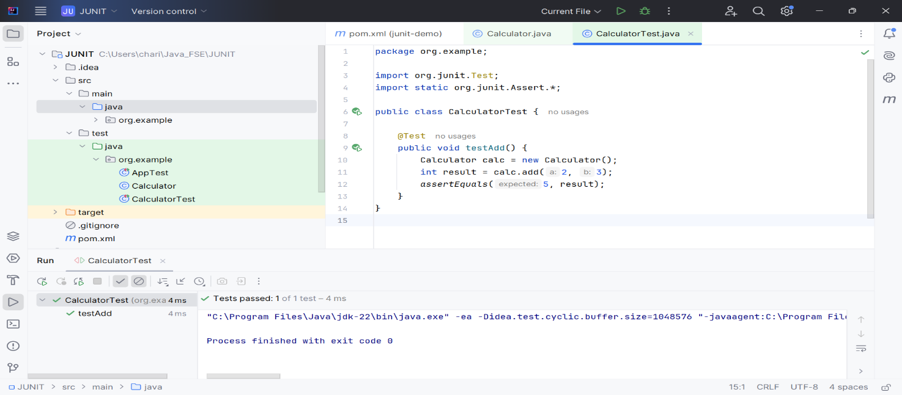

Exercise 3: Assertions in JUnit

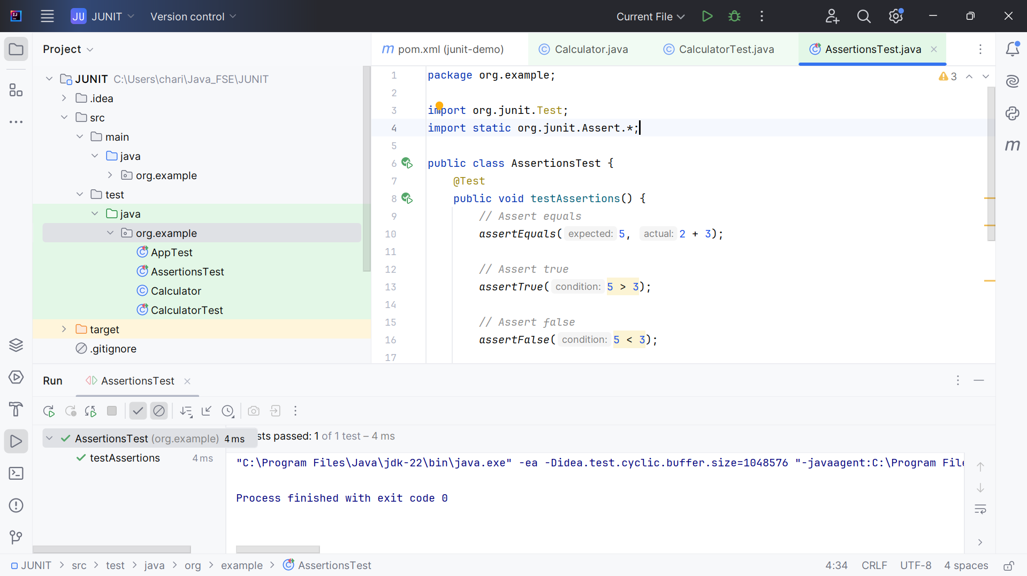

Exercise 4: Arrange-Act-Assert (AAA) Pattern, Test Fixtures, Setup and Teardown Methods in JUnit

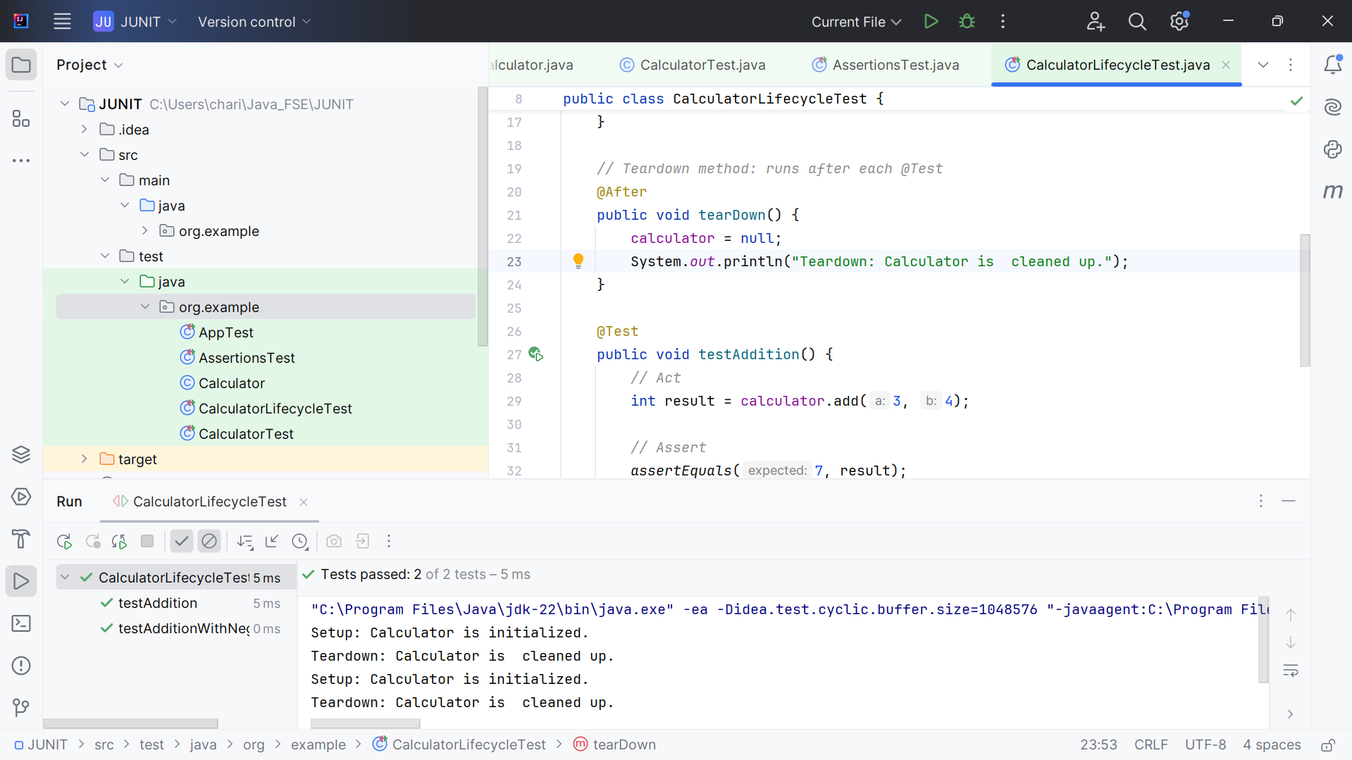

(same as above)

3. Mockito exercises

Exercise 1: Mocking and Stubbing

Output : Tests passed: 1 of 1 test – MyServiceTest

Exercise 2: Verifying Interactions

Output :Wanted but not invoked:

mockApi.getData();

6. SL4J Logging exercises

Exercise 1: Logging Error Messages and Warning Levels

Output:

[main] ERROR org.example.LoggingExample - This is an error message

[main] WARN org.example.LoggingExample - This is a warning message